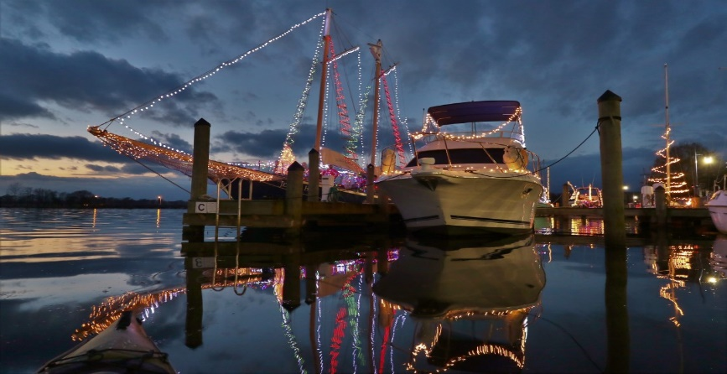

Harbor Walk of Lights 2022

The Washington Harbor District Alliance and the Waterfront Docks, Moss Landing Marina, and Havens Wharf Marina invite you to participate in the Harbor Walk of Lights 2022!

Decorate your boat and show your holiday spirit for boaters and visitors to Washington and you could be in line for prizes offered by local merchants and the WHDA. Your boat should be lit from the evening of Saturday, December 3rd through Christmas.

Boats will be judged on how festively they convey “Christmas Cheer” to make the hearts feel warmer and communicate that special feelings you only get at Christmas time.

Once your boat is decorated, you’ll take a photo that shows her to best advantage and send it to the WHDA (mhowdy@whda.org) for the electronic voting. Paper ballots will be available at the entrance to each dock.

Again, this year, awards will be based on votes submitted online and on paper ballots by visitors between early December and the evening of December 26th. In case of a tie in total votes, the higher number of paper ballot votes will be the tie breaker. Prizes will be awarded, and the winners announced in the Washington Daily News.

A limited number of slips with special incentives for participating boats are still available along the Waterfront Docks. Moss Landing and Havens Wharf have also offered special incentives and recognition in the past.

The prizes will be great, but the real reason for joining will be to add to the Harbor District Holidays festivities in Washington, and to earn the bragging rights for being the best on the Harbor Walk of Lights!

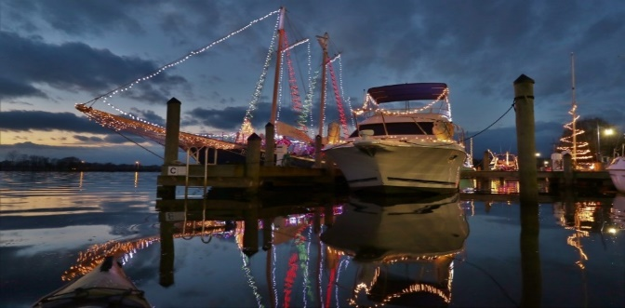

Harbor Walk of Lights 2022
Registration

- Complete the information below to register your boat and compete for prizes offered by local merchants. Turn the registration form into the Dock Attendant at the Washington Waterfront Docks. He’s there from 8AM to Sunset every day.
- Decorate your boat to display “Christmas Cheer” – to make hearts warmer and communicate the special feelings of the holiday. Your boat should be lit each evening from December 3rd until Christmas.
- Take a photo of your boat that shows her to best advantage. Email that photo to the Washington Harbor District Alliance at mhowdy@whda.org . They will post your photo to Facebook and use it in the online voting.
- You will be given a placard with a number on it; the number will help visitors identify your boat on the paper ballots. Mount the placard in a spot where it can be seen by folks walking past the docks.
- Votes will be counted during the week of December 26th, and prizes will be awarded based on the total of online and ballot votes received. In the event of a tie, the higher number of votes on paper ballots will be the tie breaker.
- Winners will be announced in the Washington Daily News.

Name: __________________________________________________________________
Address: ______________________________ City, St, Zip: ________________________
Cell: ___________________________ Email: ___________________________________
Boat Name: _________________________ Power or Sailboat? _____________________
Location of your boat: Marina: _____________________ Slip Number: ________________
Describe your boat: _________________________________________________________

FOR QUESTIONS CALL THE WASHINGTON WATERFRONT DOCKS AT 940-1231 OR 944-6661

