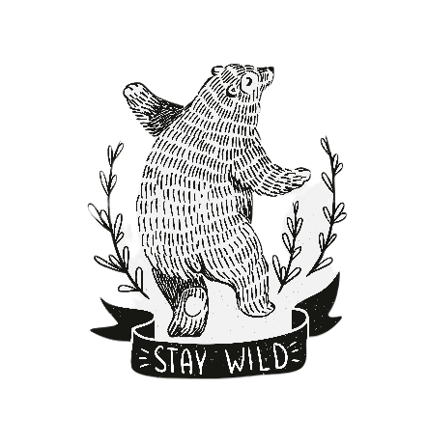
Mac “Bear” Hodges Music Festival
Saturday, September 24th, 2022
2-8 PM
Sponsorship Programs
Producer $5,000 (Only one available)
- Naming rights of the Mac “Bear” Hodges " Music Festival presented by...."
- Logo/Company name included in all television, radio, website & Washington Daily News advertising
- Prime booth location the day of the festival
- Special thank you by the bands throughout the day & opportunity to speak & introduce the bands
- Radio advertising mentions your company as presenting sponsor
- 20 - 2022 Music Festival t-shirts & hats
- Logo displayed on banner at the main stage
- Special recognition as a Presenting sponsor in the 2022 Music Festival Schedule of Events,
as event sponsor on Music Festival social media page, and WHDA events website
- Company Logo and recognition as event sponsor on Music Festival social media page and WHDA events website
- VIP tent for 20 with dedicated VIP bar and ECU football watching station
Rock Star $2,500
- Logo/Company name included in all television, radio, website & Washington Daily News advertising
- Special thank you by the band during performances throughout the day
- 12- 2022 Music Festival t-shirts
- Logo/Company name displayed on banner at the main stage
- Special recognition as a major sponsor in the 2022 Music Festival Schedule of Events
- Logo/Company name & recognition as event sponsor on Music Festival social media page & WHDA events website
- Company spotlight on social media and website homepage before the Music festival
- VIP seating for 12 with dedicated VIP bar and ECU football watching station
Headliner $1,500.00
- Logo/Company name included in all television, radio, website & Washington Daily News advertising
- Special thank you by the band during performances throughout the day
- 8- 2022 Music Festival t-shirts
- Logo displayed on banner at Music Festival
- Special recognition as a major sponsor in the 2022 Music Festival Program Schedule of Events
- Company Logo and recognition as event sponsor on Music Festival social media page and WHDA events website
- VIP seating for 8 with dedicated VIP bar and ECU football watching station
Indie $1,000.00
- Logo/Company included in all television, radio, website & Washington Daily News advertising
- Logo on a banner placed around town the week of the Music Festival and during the Festival
- 6 - 2022 Music Festival t-shirts
- Logo Space in 2022 Music Festival Schedule of Events
- Company Logo & recognition as event sponsor on Music Festival social media page & WHDA events website
- VIP seating for 6 with dedicated VIP bar and ECU watching station
Groupie $500.00
- Sponsor Logo in Mac “Bear” Hodges Music Festival Washington Daily News Ads
- 4 - 2022 Music Festival t-shirts
- Logo displayed on a banner at Music Festival
- Logo Space in 2022 Music Festival Schedule of Events
Fan $250.00
- Sponsor name listed in Mac “Bear” Hodges Music Festival Washington Daily News Ads
- Name listed on a banner at Music Festival
- 2 - 2022 Music Festival t-shirts

