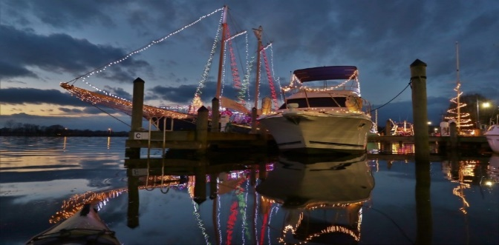

Harbor Walk of Lights 2021
Registration

- Complete the information below to register your boat and compete for prizes offered by local merchants. Turn the registration form in to the Dock Attendant at the Washington Waterfront Docks. He’s there from 8AM to Sunset every day.
- Decorate your boat to display “Christmas Cheer” – to make hearts warmer and communicate the special feelings of the holiday. Your boat should be lit each evening from November 23rd until Christmas.
- Take a photo of your boat that shows her to best advantage. Email that photo to the Washington Harbor District Alliance at mhowdy@whda.org . They will post your photo to Facebook and use it in the online voting.
- You will be given a placard with a number on it; the number will help visitors identify your boat on the paper ballots. Mount the placard in a spot where it can be seen by folks walking past the docks.
- Votes will be counted until the evening of December 26th, and prizes will be awarded based on the total of online and ballot votes received. In the event of a tie, the higher number of votes on paper ballots will be the tie breaker.
- Winners will be announced in the Washington Daily News.

Name: __________________________________________________________________
Address: ______________________________ City, St, Zip: ________________________
Cell: ___________________________ Email: ___________________________________
Boat Name: _________________________ Power or Sailboat? _____________________
Location of your boat: Marina: _____________________ Slip Number: ________________
Describe your boat: _________________________________________________________

FOR QUESTIONS CALL THE WASHINGTON WATERFRONT DOCKS AT 940-1231 OR 944-6661

